**DATA VISUALISATION USING TABLEAU INTERNAL ASSESSMENT**



**QS**

**WORLD**

**UNIVERSITY RANKINGS**

**2017 TO 2022**

**DIGVIJAY SINGH**

**NAVIN BALA**

**INTRODUCTION**

**QS World University Rankings is an annual publication of university rankings by Quacquarelli Symonds (QS).**

**Quacquarelli Symonds (QS) is a British company specializing in the analysis of higher education institutions around the world. The company was founded in 1990 by Nunzio Quacquarelli.**

**The dataset contains data of the TopWorld Universities Ranking from 2017 to 2022. The dataset was downloaded from Kaggle. It consistsof information like Name of the university, Ranking of the university, Score of the University, and in which Country and City its located, Type of the University, Research Output of the University, Student Faculty Ratio, International Students strength and Faculty Count of the University.**

**DATA AFTER CONNECTED TO TABLEAU**

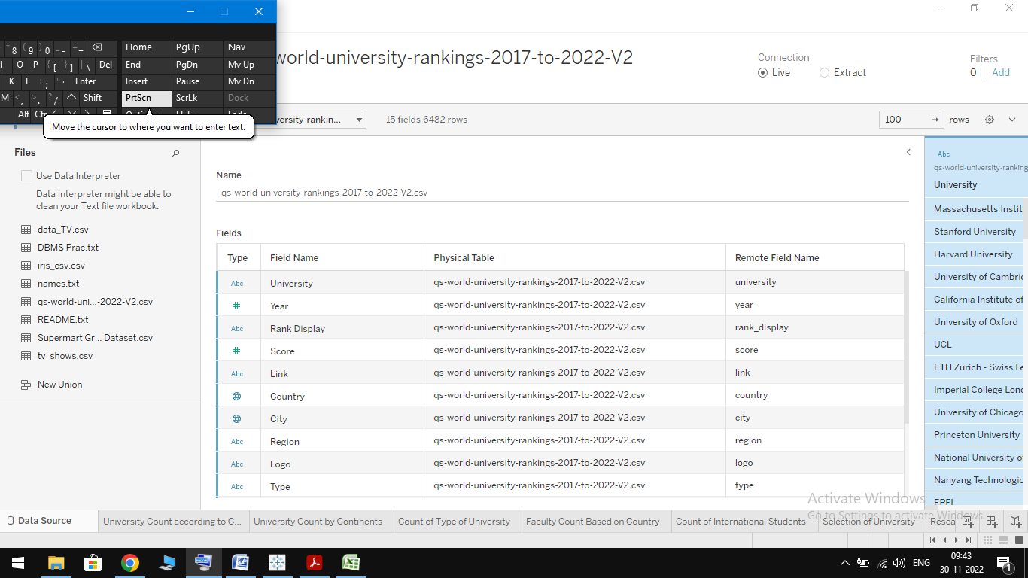

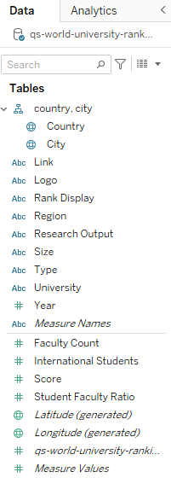

**When the dataset is connected**

**to Tableau,Tableau automatically**

**assigns certain role to**

**the data.University, Rank,**

**Link, Region, Logo,**

**and Type are Dimensions.**

**Whereas Year and**

**Scores are Measures.**

**1] What are the University Count according to Country?**

* **Add Country to Columns Shelf.**
* **Drag University to Rows Shelf and select**

**Measure Count. Click Control and drag**

**CNT(University) to Size.**

* **From show me section select Symbol Maps.**
* **Drag and Drop Country in Color, Label and Detail in the Marks Card.**

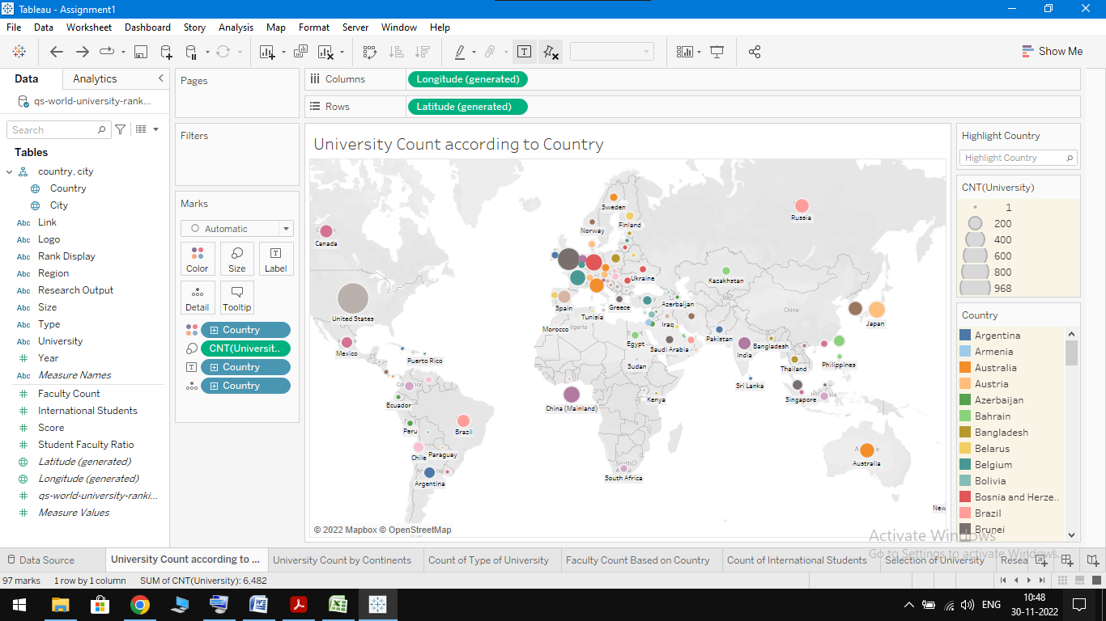

**2]What Are the University Count by Continents?**

* **Drag Region from Data Panel and drop it in Columns Shelf.**
* **Drag and drop University in row Shelf.**
* **From Show Me Section Select Stacked bars option.**
* **Drag Type and Drop it in Color in Marks panel Section.**

**3] Count of Type of University.**

* **Drag Type from Data Panel and Drop it in Rows Shelf.**
* **In the Marks Card Dropdown menu, select Square.**
* **Drag and Drop Region in Color and Label in Marks Card Section.**
* **Change the Region Measure to Count.**

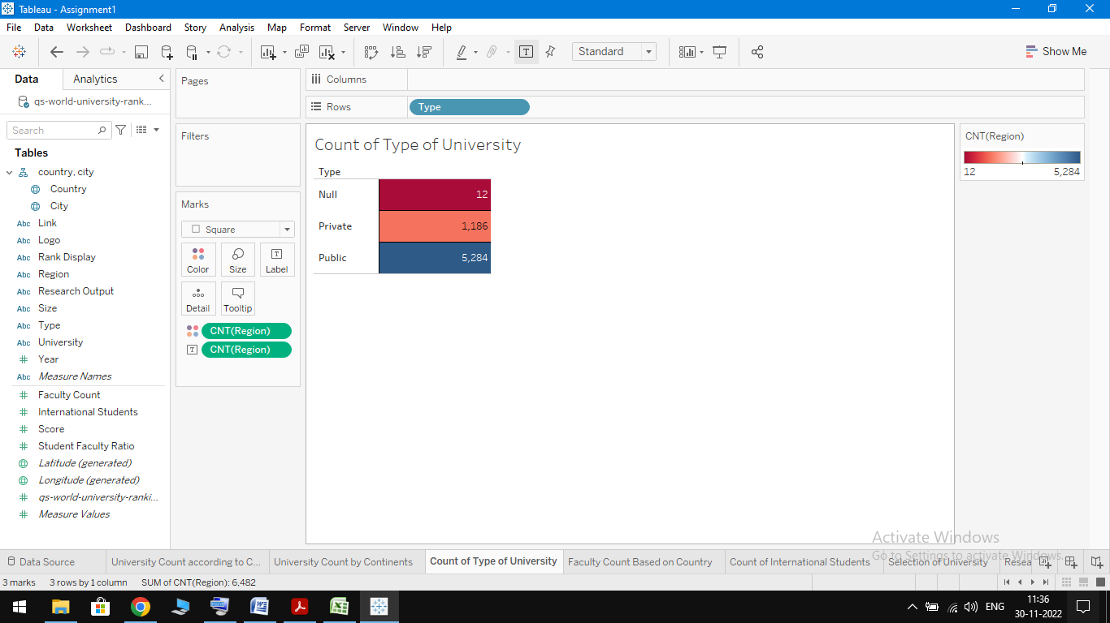

**4] Faculty Count Based on Country.**

* **Drag Country From data panel and drop it in Columns Shelf.**
* **Drag and Drop Faculty Count in Rows Shelf.**
* **From Show Me section select Symbol Maps option.**
* **Drag and drop Country in Detail and Faculty Count in Colorof Marks Card Section.**

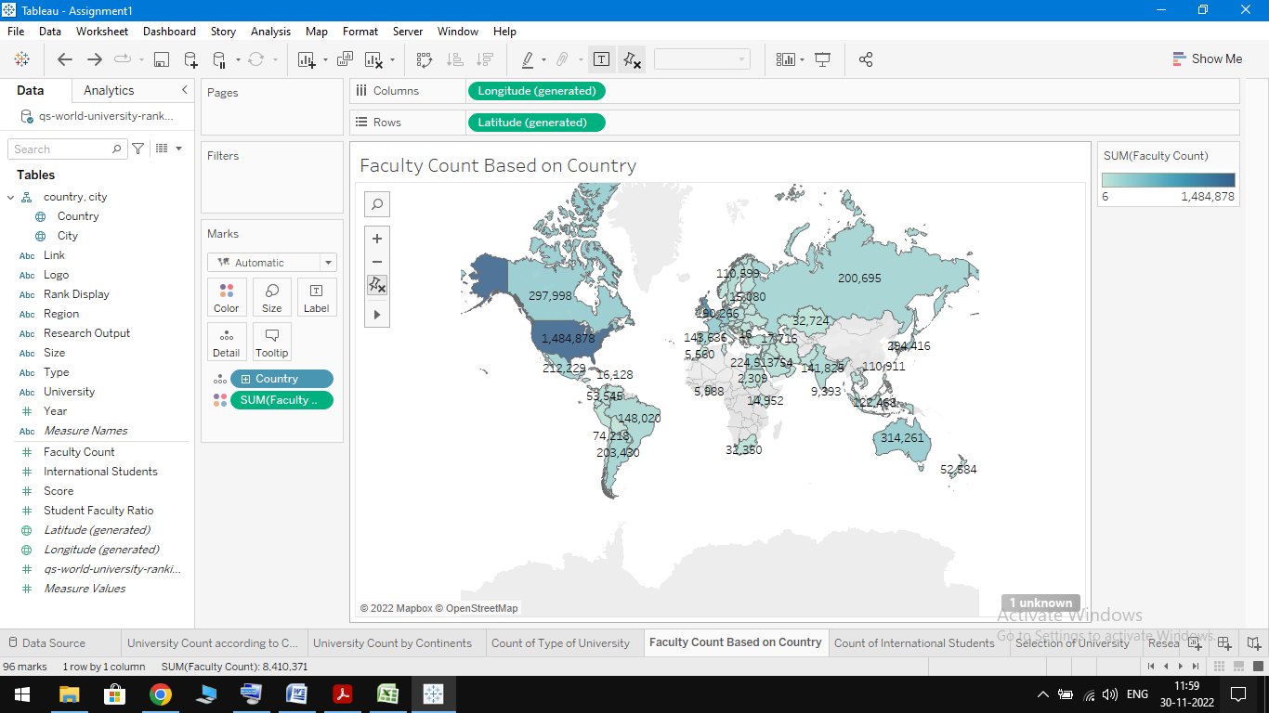

**5] What are the Count of International Students?**

* **Drag Region from data panel and Drop it in Columns Shelf.**
* **Drag and Drop International Students in Rows Shelf and set Measure type as Count**
* **Repeat the above Step one more time.**
* **From Show Me Section Select Dual Combination.**
* **Drag and Drop Measure Name in Color of Marks Card section.**

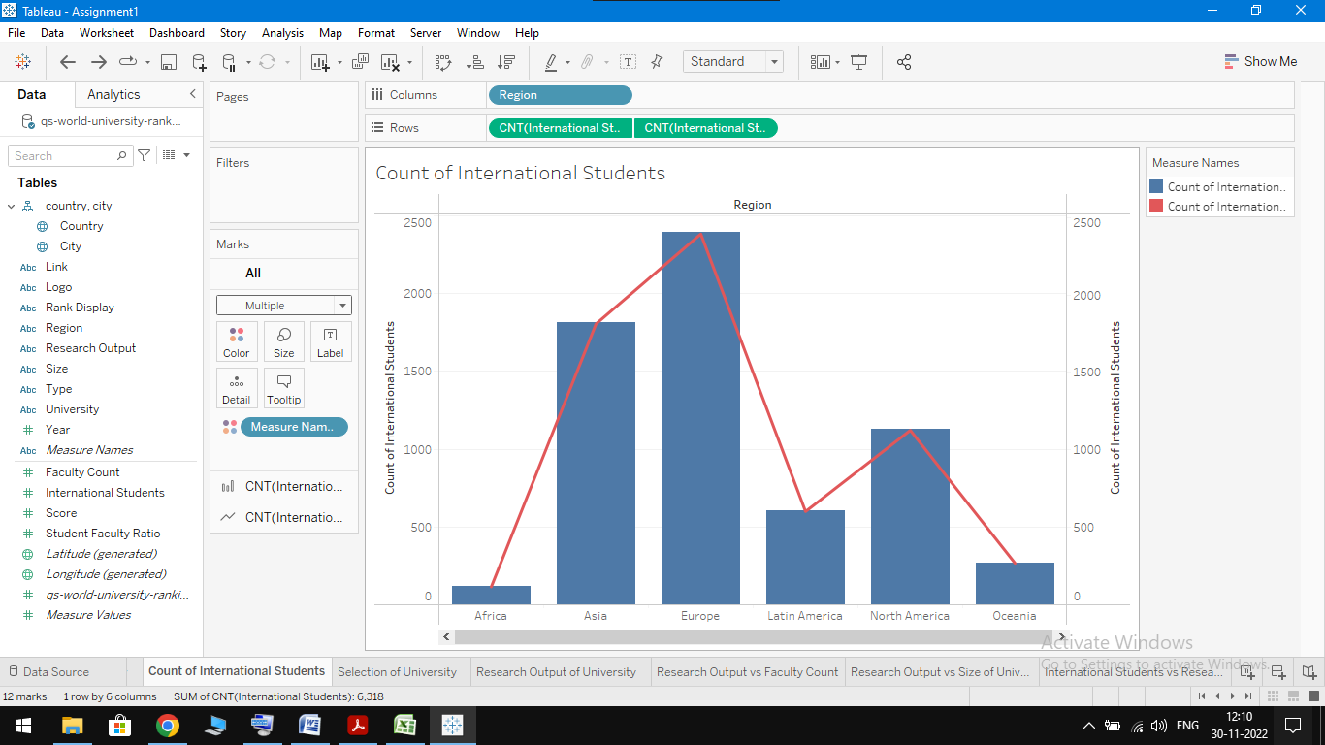

**6] How Many Students Choose Public and Private University?**

* **Drag and Drop Type in the Columns Section.**
* **Drag and Drop International Studentsin the Rows Section.**
* **From Show Me Section Select Horizontal Bars Options.**
* **Drag and Drop International Students in Color and Text of Marks Card Section.**

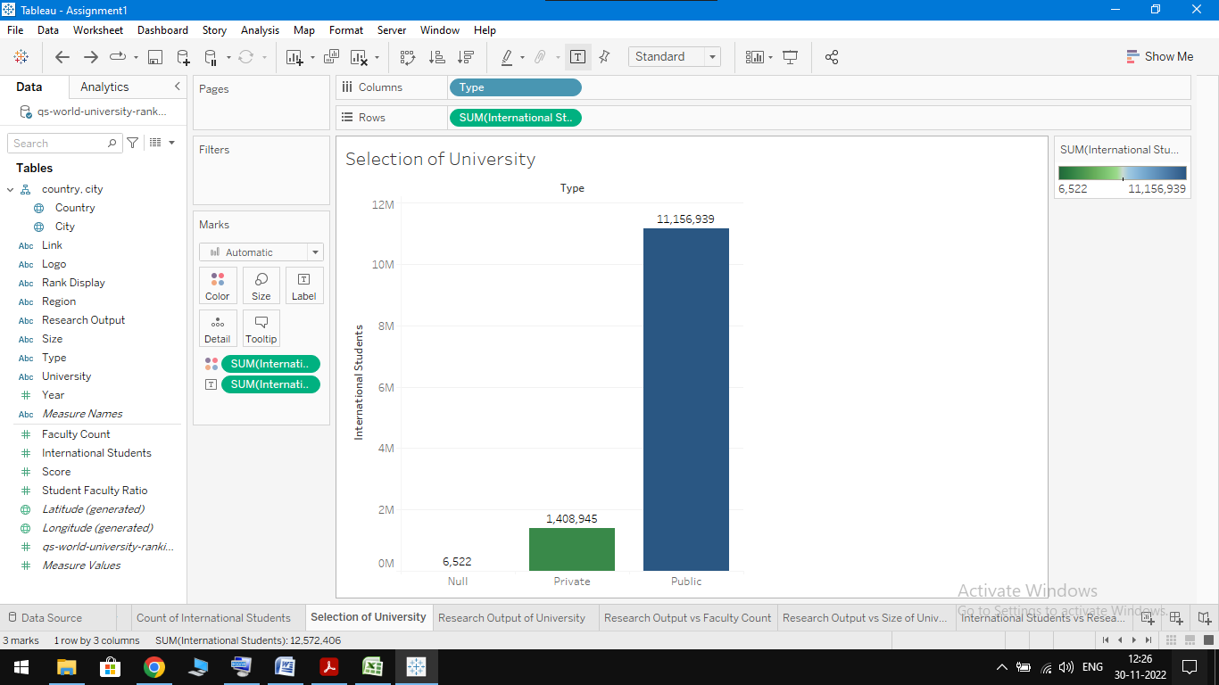

**7] Research Output of University.**

* **Drag and Drop Research Output in Columns Shelf.**
* **Drag and Drop Type in Rows Shelf and change its Measure to Count.**
* **From Show Me Section Select Stacked Bars Option.**
* **Drag and Drop Type in Color in Marks Card Section.**

**8] Research Output vs. Faculty Count**

* **Drag and Drop Type and Research Output in the column Shelf.**
* **Drag and Drop Faculty Count in the Rows Shelf and change its Measure to Count.**
* **From Show Me Section Select Horizontal Bars Option.**
* **Drag and Drop Research Output in Color and Faculty Count in Label [Change Faculty Count Measure to Count] Of Marks Card Section.**

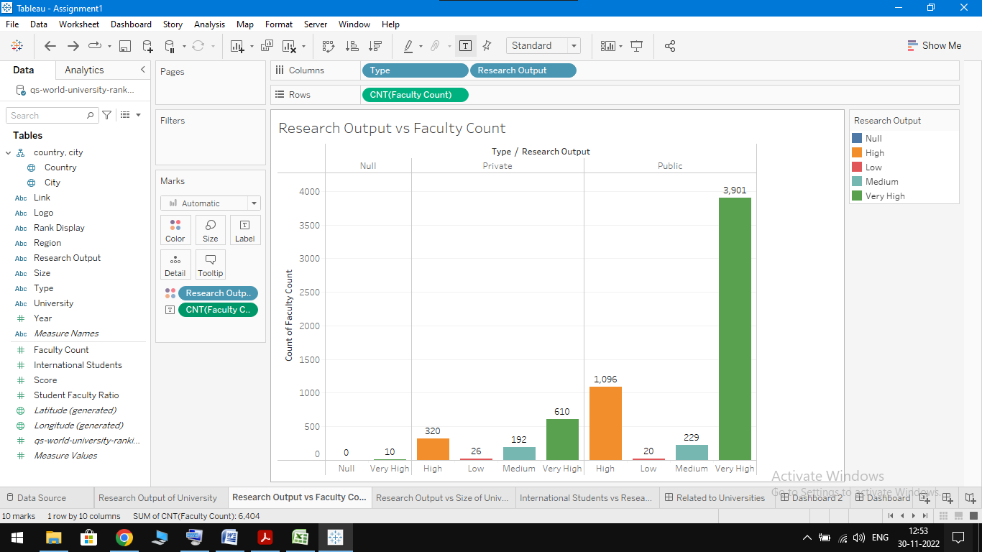

**9] Research Output vs. Size of University**

* **Drag and Drop Research Output in Columns Shelf.**
* **Drag and Drop Size in Rows Shelf and change its Measure toCount.**
* **In the Marks Card Dropdown menu, select Line.**
* **Drag and Drop Size in Color of Marks Card Section.**

**10] International Students vs. Research Output.**

* **Drag and Drop Research Output in Columns Shelf.**
* **Drag and Drop International Studentsin the Rows Shelf andChange its Measure to Count.**
* **In the Marks Card Dropdown menu, select Line.**
* **Drag and Drop Type in Color of Marks Card Section.**

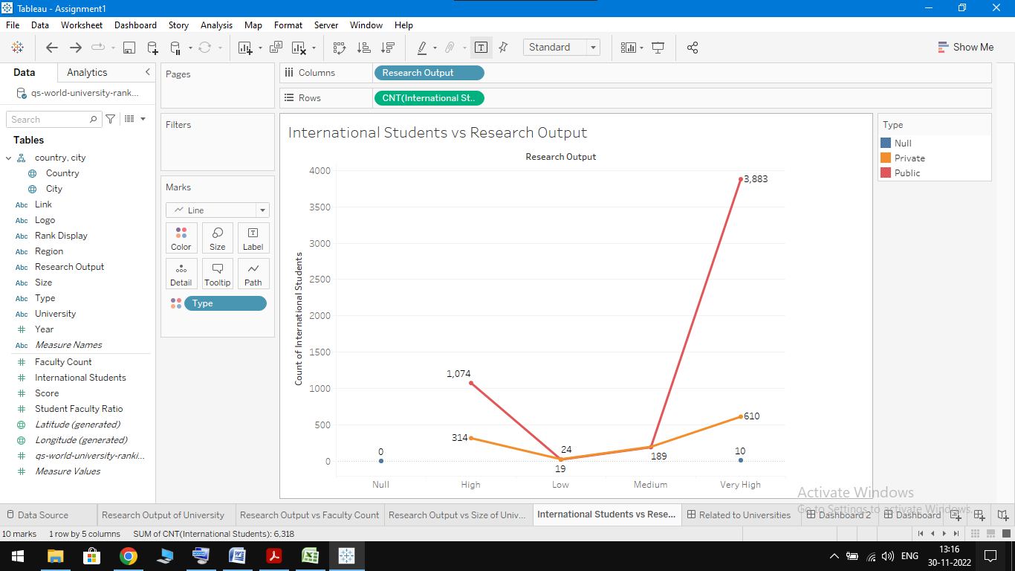

**11] Dashboard.**

* **From Menu Bar Select Dashboard and then Click on New Dashboard.**
* **From Sheets Section Select University Count according to Country, University Count by Continents, Count of Type of University.**

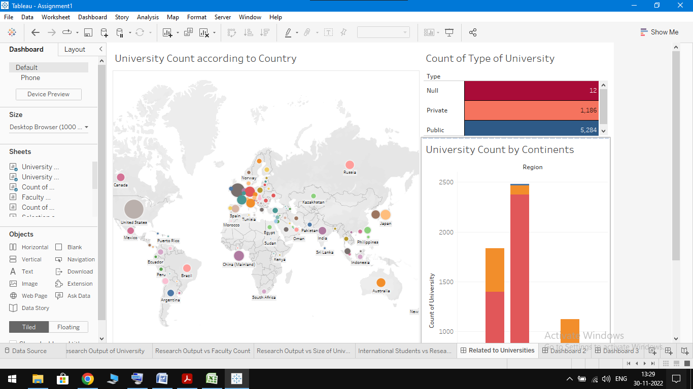

**12] STORY.**

* **From Menu bar Click on Story then click New Story.**
* **Now Drag and Drop Sheet From Story Pane which is present in left side.**

